Week 1 Task: Data Acquisition, Cleaning & EDA Report
Author: Nune Venkata Yasasvi
Dataset: Titanic Passenger Cleaned Dataset (891 records)
------------------------------------------------------------

1. Executive Summary & Data Cleaning Rationale
The primary objective of Week 1 was to execute an end-to-end data preparation and exploratory analysis workflow. The following cleaning procedures were implemented:
• Missing Age Handling: Imputed missing age records using the median age grouped by passenger class (Pclass) to preserve socio-economic stratification.
• Missing Embarked Handling: Imputed missing categorical values using the mode ("S").
• Column Dropping: Dropped the "Cabin" column due to an excessive proportion (>77%) of missing entries.
• Deduplication: Verified zero duplicate rows present in the raw dataset.

2. Exploratory Data Analysis & Visual Outputs

Data Completeness Check
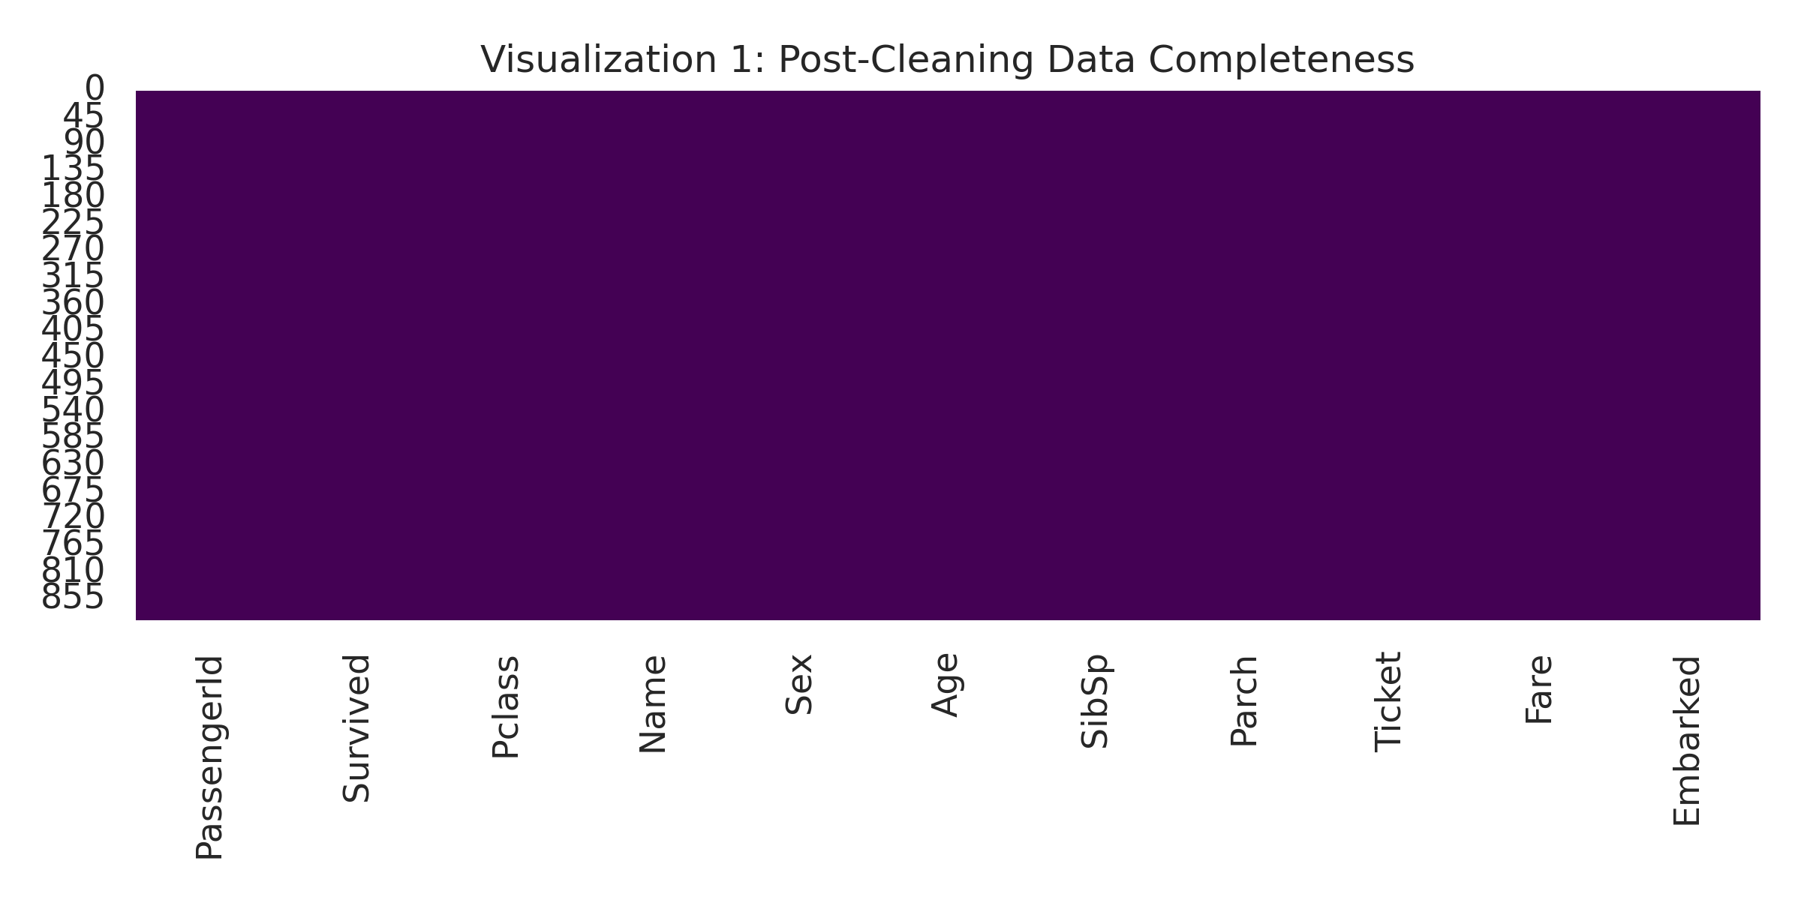

Demographic Trends vs. Survival
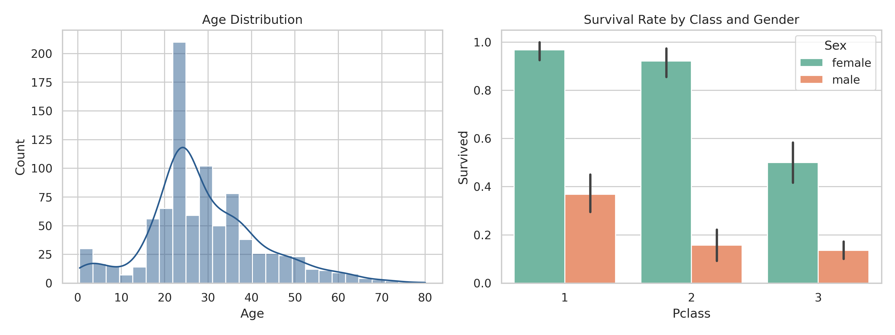

Numerical Feature Correlations
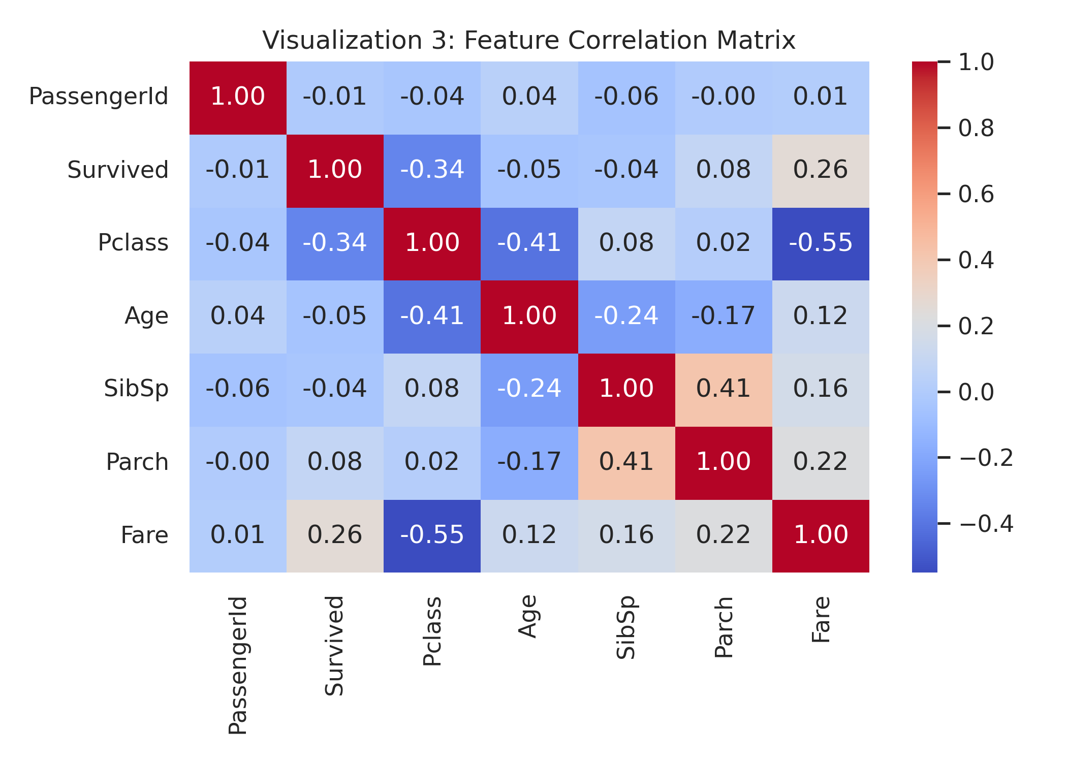

3. Key Analytical Insights
- 1. Demographic Disparity: Females demonstrated a drastically higher survival rate across all passenger classes compared to males.
- 2. Socio-Economic Class Effect: First-class passengers (Pclass 1) achieved significantly higher survival odds than third-class passengers (Pclass 3).
- 3. Fare Correlation: Ticket fare shows a positive correlation (+0.26) with survival outcome, corroborating the Pclass trend.

